## Introduction

Beach morphology change has long been used as a measure for coastal management and planning studies. For example, the success of coastal protection projects (e.g. structures, nourishments) is often measured by their ability to increase beach area or volume. The position of the shoreline is a representative indicator of beach change, with a strong linear correlation between shoreline position and beach volume (Bryan & Smith 2007). For these reasons, improving our understanding of shoreline variability over multiple spatial and temporal scales is a key priority for coastal geoscience and engineering (Power et al. 2021). From short- (days to weeks) to long-term (years to decades) timescales, driving factors of shoreline change can include storm events, seasonal shifts in the wave climate, periodic changes to climate variability indices (e.g. El Nino Southern Oscillation, North Atlantic Oscillation) and global climate change (e.g. sea level rise).

Mountainous or hilly coastlines associated with embayed (or headland bay) beaches form about 50% of the world’s coasts (Inman & Nordstrom 1971). Shoreline change research focused on an embayed beach can therefore be applied with global significance. Unless headland bypassing is a common occurrence (e.g. Silva et al. 2021), these embayed beaches are generally described as closed systems where sediment is contained between two headlands, structures or rocky outcrops. (link) Instead, beach rotation is a dominant mode of shoreline variability at embayed beaches where sediment transport results in an apparent out-of-phase shift in shoreline position at each end of the beach (Short & Masselink 1999, Klein et al. 2002, Turki et al. 2013).

There is notable variability in the dominant driving hydrodynamic factors of beach rotation, with both the reversal of longshore sediment transport (Klein et al., 2002) and longshore variability in cross-shore sediment transport (Harley et al., 2015) found to be important. Beach rotation is often linked to seasonal shifts in the wave climate (Turki et al. 2013, …), including both wave direction and significant wave height. However, climate drivers such as El-Nino Southern Oscillation (Short et al., 2000; Ranasinghe et al., 2004) and North Atlantic Oscillation (Thomas et al., 2011) have also been linked to beach rotation. Understanding this coastal process requires a spatio-temporal analysis of the whole beach (Klein et al., 2002). However, beach profiles or shoreline transects at either end of a sandy embayment have been used with great success to measure the magnitude and timescales of suspected beach rotation (e.g. Ranasinghe et al. 2004).

The Southern Annular Mode (SAM) is a dominant mode of Southern Ocean climate variability (Rogers & van Loon 1982, Simmonds 2003). The Southern Ocean is well known for its persistent and strong storm belt associated with low-pressure and frontal systems. These intense winds are responsible for much of the ocean swells globally, across the southern hemisphere and even into the North Pacific (Young 1999). SAM is measured using an index (SAMI) described by zonally-averaged, mean sea-level pressure differences between 40°S and 65°S (Marshall, 2003). A positive (negative) SAMI value corresponds to higher (lower) pressure at 40°S than at 65°S. Hence, the Southern Ocean storm belt shifts south (north) during a positive (negative) phase of SAM.

Unsurprisingly, there is a correlation between this measure of the Southern Ocean storm belt position and the significant wave height across the southern coast of Australia (Hemer et al., 2009). Larger wave heights for positive phases of SAM during Austral autumn and winter (positive correlation), but a negative correlation between SAMI and wave height during Austral summer months was identified (Hemer et al., 2009). Liu et al. (2022) confirmed these results with a high-resolution wave model for Bass Strait (see Fig. 1(b) for specific study area) but suggested a weaker relationship during summer months when locally generated waves became more significant. Due to its link to the wave climate variability, it is hypothesised that SAM could be a driving factor for beach rotation at embayed beaches exposed to the Southern Ocean swells. By identifying a relationship between beach rotation and the SAM climate index, coastal scientists will be able to predict shoreline change more accurately at longer timescales. Also, SAMI values have shown a long-trend to more positive values associated with climate change (Fogt and Marshall, 2020). Hence, any relationship between shoreline variability and SAM may be used to better predict coastal change into the future.

This research used freely available satellite imagery to measure the shoreline position between 1987 and 2020 (inclusive) at a sandy embayed beach on the southern coast of Australia. The timescales and magnitude of beach rotation were then assessed by comparing shoreline position at either end of the embayment using beach transects. Further analysis was conducted using principal component analysis applied to the spatio-temporal variability in the shoreline position data. Beach rotation at the seasonal timescale and its relationship to the different phases of SAM was a particular focus of the results. Applications for future research at other beaches exposed to the Southern Ocean swells, and for coastal geoscience and engineering are then discussed.

## Study area: Grassy Beach (King Island, Australia)

Grassy Beach (144.055°E, 40.065°S) is a south-facing, sandy embayment on King Island in western Bass Strait, between the Australian mainland and Tasmania (see Fig. 1). The beach is about 1.4 km long, situated between a natural headland to the west-southwest and a series of rocky training walls associated with the Port of Grassy to its east. The beach is composed of fine to medium sand (D50 ≈ 0.23 mm), has a relatively mild beach slope (tanβ ≈ 0.045) and is microtidal with a spring tidal range of 1.4 m (Cossu et al., 2020; Lancaster et al., 2022; Short, 2006). Grassy Beach is partially protected from the strongest winds and largest waves associated with the Southern Ocean by its rocky headland, and easterly storms by the training wall to its east. A recent field study recorded a maximum significant wave height in the bay of 2.4 metres between January and September 2021 (Lancaster et al., 2022). In comparison, the long-term average wave height outside the embayment is approximately 3 metres (Liu et al., 2022).

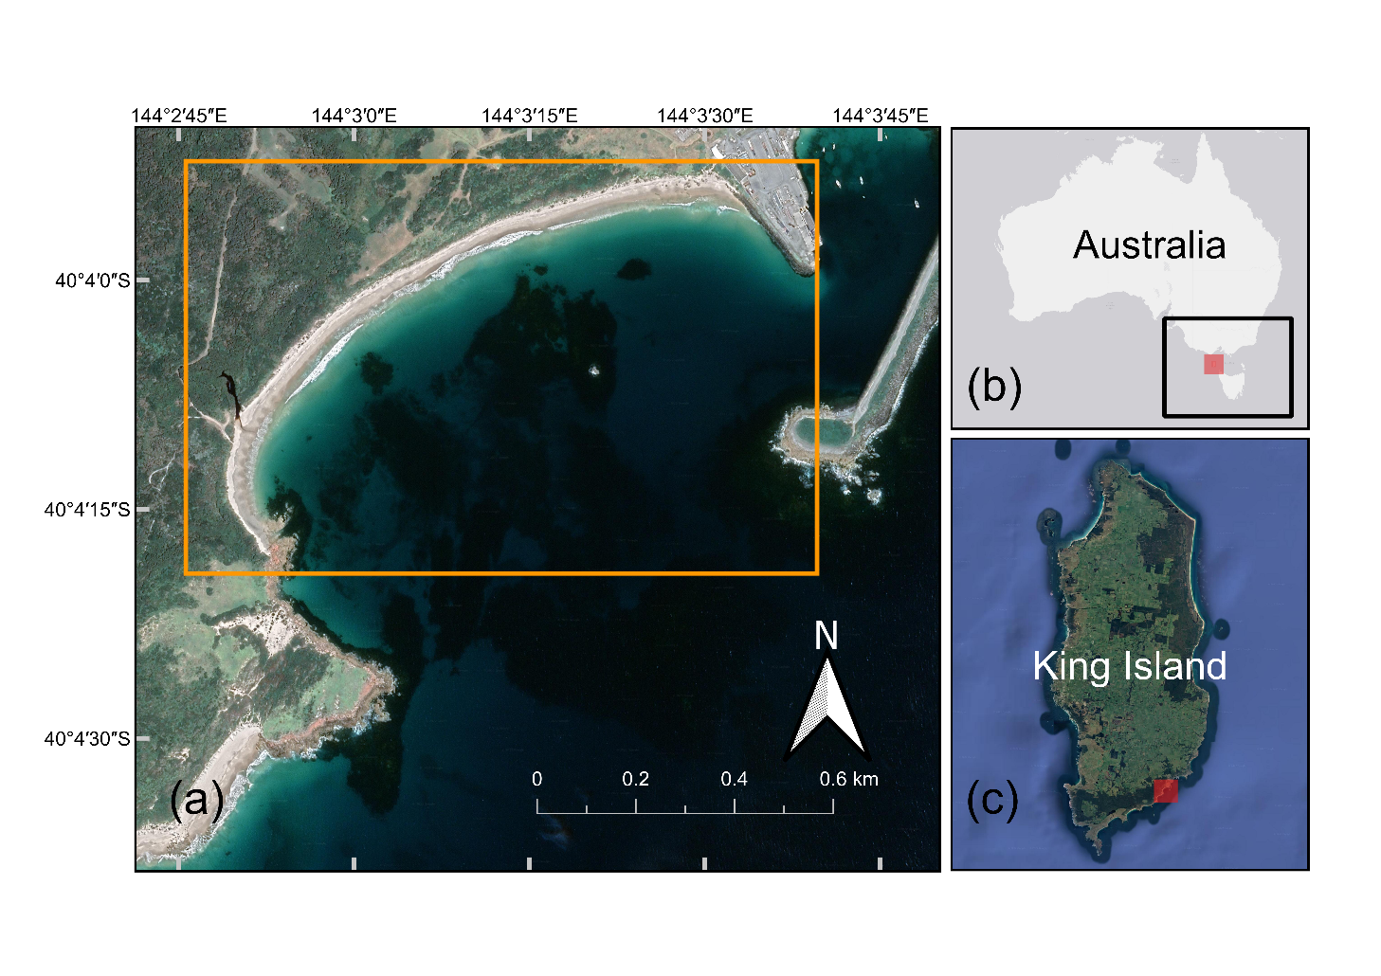

Fig. . (a) Location of the study area with the CoastSat extent shown in orange; (b) Australia map with King Island (red) in relation to the Bass Strait study region (black) from Liu et al. (2022); (c) King Island map with Grassy Beach location (red).

A Bass Strait sandy embayment was chosen for this study such that the findings from Liu et al. (2022) related to SAM’s influence on the Bass Strait wave climate could be applied. Specifically, Grassy Beach was chosen as it is a current wave energy converter development site (Lancaster et al., 2022). Hence, this research will be directly relevant to future research focusing on the environmental impacts of this wave energy converter by providing a baseline for natural shoreline variability at the study site.

## Methods

A satellite-derived shoreline dataset for 1987 to 2020 (inclusive) was created using the Coastsat toolkit (Vos et al., 2019). This dataset was used to produce a time series of tidally corrected shoreline position at 25 transects (50 metres apart) along Grassy Beach. This data was analysed against SAMI data and seasonal shifts in wave climate to understand the timescales and magnitude of shoreline variation at this sandy embayment. Empirical orthogonal function (EOF) analysis of the shoreline position data was also performed to quantify the effect of beach rotation and other coastal processes on the measured shoreline variability.

### Satellite-Derived Shoreline Detection

Shoreline position along Grassy Beach was measured using a satellite-derived shoreline (SDS) technique. The CoastSat toolkit was used, which is freely available on GitHub (<https://github.com/kvos/CoastSat>) and described in detail in Vos et al. (2019). Briefly, CoastSat defines the shoreline position as the sand/water threshold. Satellite images are retrieved from Google Earth Engine, and then using a sub-pixel detection algorithm is used to determine this shoreline. The algorithm detects sand, white-water and water using the Modified Normalized Difference Water Index (MNDWI) from the short-wave infrared band and green bands of the satellite before determining the sand/water threshold at sub-pixel resolution using a Marching Squares algorithm (Vos et al., 2019b). This method has been shown to be relatively accurate with a root-mean-squared error between 7 and 15 metres, with better accuracy at microtidal sites and after performing tidal correction (Castelle et al., 2021; Vos et al., 2019a, 2019b).

For this study, CoastSat was used to extract shoreline data from Landsat 5 (L5), Landsat 7 (L7), Landsat (L8) and Sentinel-2 (S2) optical imagery data. See Table 1 for satellite details. 1513 satellite images were extracted from Google Earth Engine for the period 1987 to 2020 (inclusive). A cloud threshold of 50% for the study area, and then quality control of the derived shorelines, left only 420 usable satellite-derived shorelines for analysis. Many of the L7 images included for analysis did not cover the entire study area (partial shorelines) due to a known scanline error (see Fig. 2 for example) in images since 2013 (Scaramuzza and Barsi, 2005). The number of useable images per year increased significantly through time with the introduction of L7, L8 and S2, such that between 1987 and 2000 there were about 6 images per year increasing to about 30 images per year from 2015 to 2020.

Table . Satellite imagery details...

|  |  |  |  |  |
| --- | --- | --- | --- | --- |
| **Satellite** | **Availability** | **Resolution (pan sharpened)** | **Recurrence Interval** | **Number of Images (Number Used)** |
| Landsat-5 | 1987 – 2011 | 30 m | ~ 16 days | 332 (123) |
| Landsat-7 | 1999 – present | 15 m | ~ 16 days | 491 (143) |
| Landsat-8 | 2013 – present | 15 m | ~ 16 days | 240 (58) |
| Sentinel-2 | 2015 – present | 10 m | ~ 5 days | 450 (96) |
|  | | | **Total** | 1513 (420) |

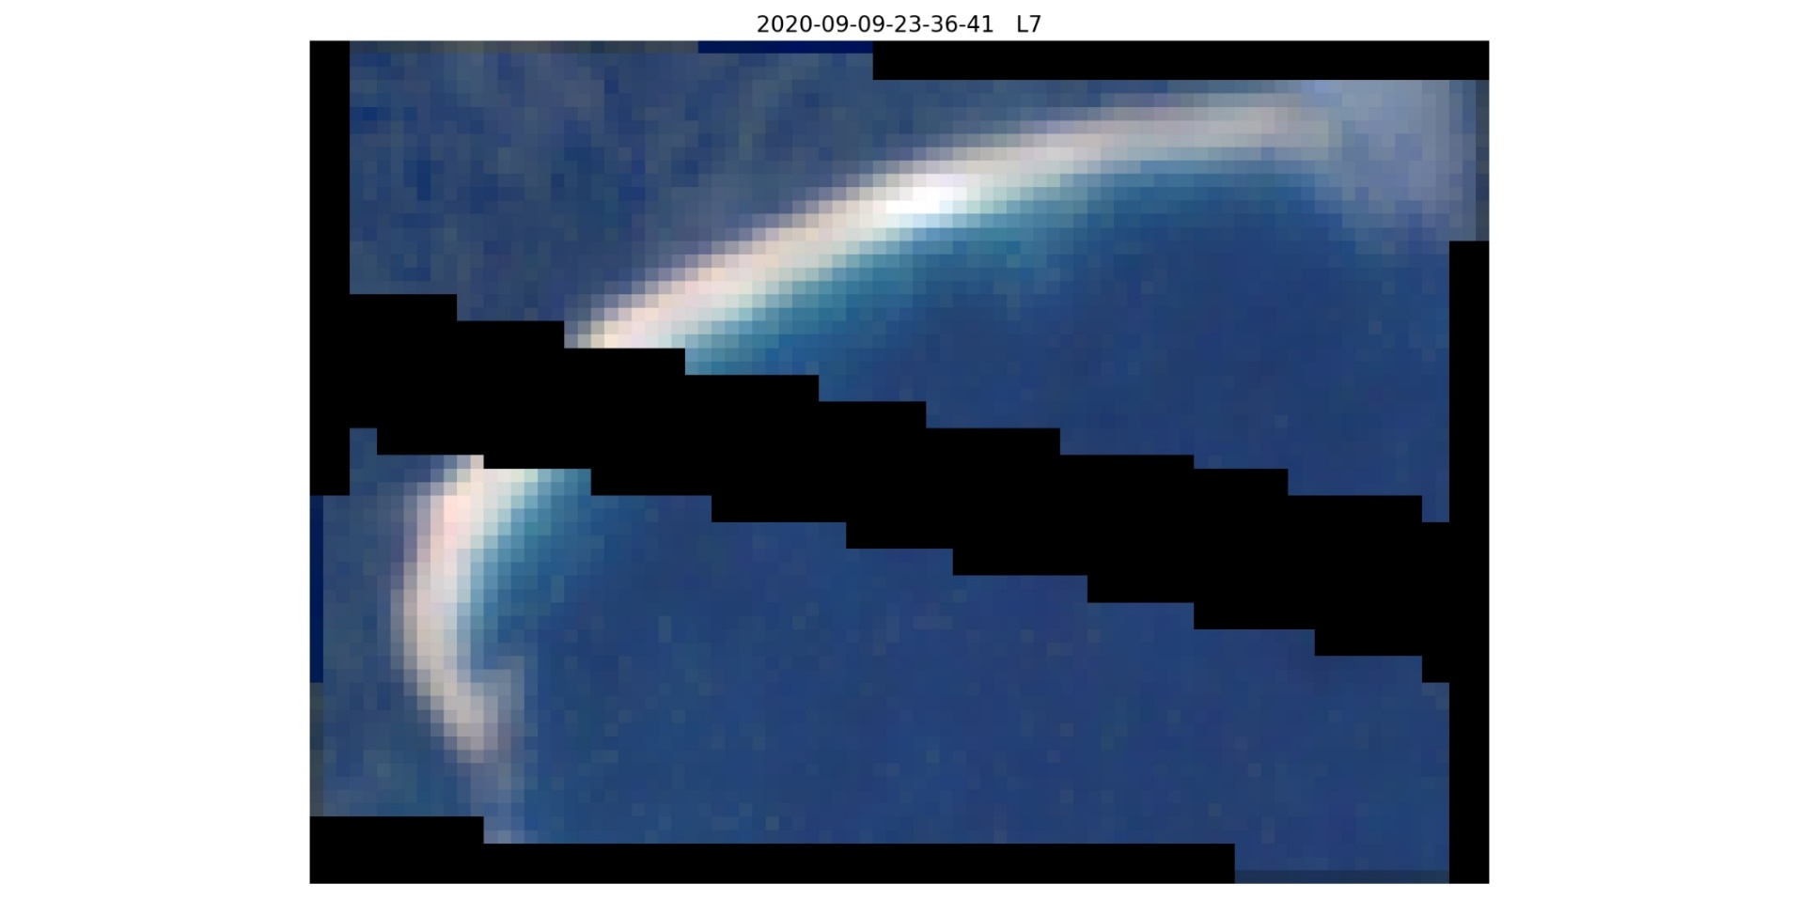

Fig. . Example of scanline error in Landsat 7 (L7) images post-2013.

Along Grassy Beach, 25 shore-normal transects were defined at 50 metre intervals along the median tidally-corrected shoreline position (see Fig. 3). Transects were created manually with QGIS software. The shoreline position for each satellite image at these transects was calculated with the CoastSat toolkit. Specifically, shoreline position was defined as the alongshore average of the shoreline points located within 25 m of the transect (Vos et al., 2019). The median shoreline position over 1987 to 2020 was subtracted from the shoreline time series to define the relative shoreline position (RSP) at each transect. A time series of tidally-corrected RSP for each transect was used for further analysis, including assessing the importance of beach rotation at the study site and the role of the Southern Annular Mode (SAM).

Fig. . Location of shore-normal transects along Grassy Beach from east to west, spaced at 50 m apart. The median satellite-derived shoreline (1987 to 2020) position is also shown (in blue).

### Wave, tide and climate index data

A linear tidal correction was applied to each satellite image at the time of image acquisition. The tidal information was obtained for Grassy Harbour (adjacent to Grassy Beach) from the Australian Bureau of Meteorology (BOM) for the period 1987 to 2020. Together with the average beach slope estimated to be 0.045 from previous topo-bathymetric survey data (Cossu et al., 2020), this data allowed for the linear tidal correction to be performed in the CoastSat toolkit.

The Southern Annular Mode (SAM) climate index was used to support analysis of the shoreline variability drivers. Monthly Southern Annular Mode Index (SAMI) data for the period 1987 to 2020 (inclusive) was obtained from <http://www.nerc-bas.ac.uk/icd/gjma/sam.html>. This index is calculated from observations of mean sea-level pressure at multiple locations at 40°S and 65°S (Marshall, 2003).

Directional wave data from a virtual CAWCR (Collaboration for Australian Weather and Climate Research) wave hindcast buoy was used to assess the wave conditions for the period 1987 to 2020. This hindcast data was derived using the WAVEWATCH III spectral wave model forced with CFSR (Climate Forecast System Reanalysis) surface winds, validated using global buoy datasets and satellite altimeter data. The buoy is located at 144°E 40.2°S, about 15 km south-south-west of the study site at a water depth of 61 m.

### Empirical Orthogonal Function (EOF) Analysis

Principal component analysis (PCA) is a statistical technique to reduce the dimensionality of a large dataset but retain as much information about the dataset’s variability in the process (Refs). It is a transformation of the dataset to a new basis, with the basis vectors directly related to the dataset’s variance. This is done by calculating eigenvalues and eigenvectors of the dataset’s correlation or covariance matrix. By choosing eigenvectors that correspond to the largest eigenvalues, this technique finds new functions to describe the dominant modes of variability in the dataset.

Empirical orthogonal function (EOF) analysis is PCA applied to spatio-temporal datasets, often used in oceanographic and climate sciences to determine dominant modes of variability (e.g. Southern Annular Mode). Two correlation matrices are calculated which show spatial and temporal variability separately, allowing for efficient analysis of the dominant modes of spatial and temporal variability. Although the corresponding eigenvalues and eigenvectors (also known as eigenfunctions or EOFs in EOF analysis) are purely mathematical in nature, the dominant eigenfunctions may closely relate to physical processes in shape. For example, the seasonal pattern of coastal change may be visible in the temporal eigenfunction associated with the EOF. Here we describe the use of EOF analysis for relative shoreline position (RSP), with the spatial eigenfunctions representing longshore variability and the temporal eigenfunctions representing temporal variability. This method is described in full by Miller and Dean (2007).

To calculate the EOFs, the RSP data, y(x,t), is represented as a matrix, **Y**, where the number of rows represents the number of transects (nx = 25) and the number of columns represents the number of timesteps that have RSP values for all transect locations (nt = 265). Note that nt is much less than the original dataset’s size (420 timesteps) due to the need to remove partial transects (largely due to L7 scanline error). Next, the correlation matrices for both spatial, **A**, and temporal, **B**, variability are calculated.

$$A=\frac{1}{n_{x}n_{t}}\left(YY^{T}\right), B= \frac{1}{n_{x}n_{t}}\left(Y^{T}Y\right)$$

The spatial ($e_{k}(x)$) and temporal ($c_{k}(t)$) eigenfunctions, and their corresponding eigenvalues ($λ_{k})$, are then calculated as follows.

$$Ae_{k}\left(x\right)= λ_{k}e_{k}\left(x\right), where k=1, …, n_{x}$$

$$Bc_{k}\left(t\right)= λ_{k}c_{k}\left(t\right), where k=1, …, n_{t}$$

Hence, the original dataset can be reconstructed from this new basis of orthogonal eigenfunctions,

$$y\left(x,t\right)=\sum_{k=1}^{N}{\sqrt{λ_{k}n_{x}n_{t}}×e_{k}(x)c_{k}(t)}, where N=min⁡(n_{x},n_{t})$$

Note that only the first N (N = 25) eigenvalues will be non-trivial (non-zero) and will be equivalent for both spatial and temporal correlation matrices. This allows for the calculation of percent of covariance ($p_{k}$) described by the kth mode of variability, $p_{k}=\frac{λ_{k}}{\sum{λ_{k}}}×100\%$, and therefore, a description of how much of the total variance is described by each eigenfunction.

For shoreline analysis, the shape of the spatial eigenfunction relates directly to shoreline variability. A local minimum (node) represents a zone of minimum shoreline variability, whereas a maximum represents a zone of large shoreline change. If the sign of the value of the eigenfunction is the same along the beach, then the beach shifts cross-shore in the same direction for that mode of variability. If the eigenfunction (EOF) flips sign along the beach, then that mode of variability is likely describing alongshore variability in cross-shore transport, where one part of the beach is eroding while the other is accreting. For this reason, spatial EOFs have been used in the past to describe beach rotation [REFs, e.g. Harley et al. 2011]. – rewrite see Miller & Dean…

## Results – paragraphs below each image are for supervisors reference

Fig. . Boxplot of relative shoreline position (RSP) at each transect along the beach from the west to east (grey). Summer (orange) and winter (blue) RSP median values are also depicted for each transect.

Fig. 4 was created from the tidally-corrected relative (to median) shoreline position (RSP) dataset for each transect. The winter vs. summer median RSP values show a distinct seasonal difference at each end of the beach.

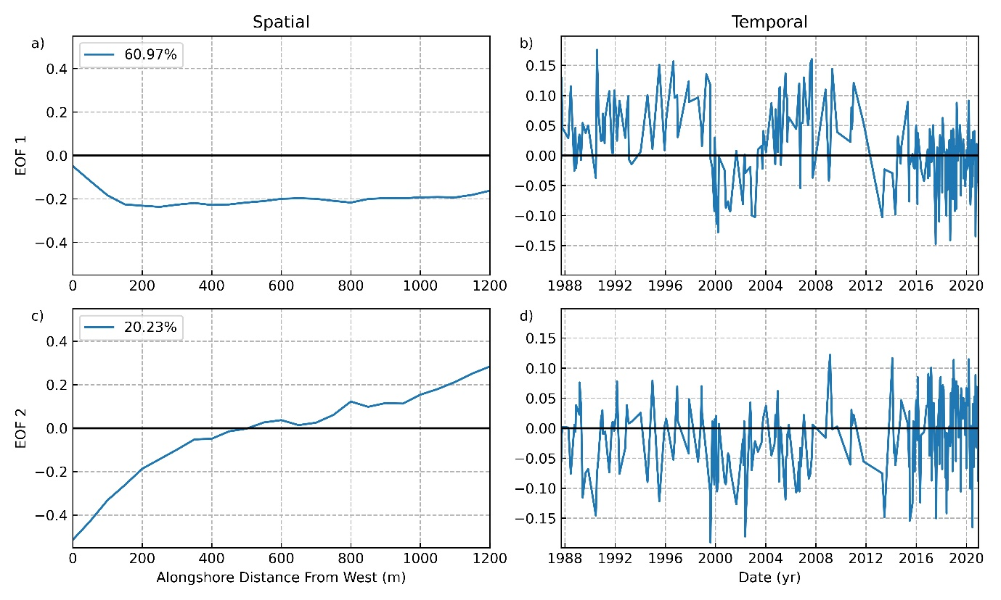

Fig. . Empirical Orthogonal Functions (EOFs) for the relative shoreline position data, showing the two (EOF 1 and EOF 2) dominant modes of spatio-temporal variability in the data. The left side (a), (c) shows the spatial EOF values for each transect as a line plot, and the right side (b), (d) shows the temporal EOF values for each timestep with a line plot. The legend in the top left of (a) and (c) show the percentage of variability described by that EOF.

Fig. 5 was created from the same dataset as figure 4 (RSP dataset), except that all timesteps with incomplete shoreline data (e.g. only half the beach covered by the satellite image, or partially covered by cloud, or from the Landsat 7 issue) needed to removed to calculate the EOFs. (EOF analysis does not work with “NaN” values). EOF 1 describes about 61% of the variability in this data, and EOF 2 20%. EOF 1 has the same sign for all transects – cross-shore transport occurs in the same direction for all transects. EOF 2 has a single node near the centre of the beach showing a transition zone and “beach rotation” signal, where one end erodes while the other accretes.

Fig. . Average value of the 2nd temporal eigenfunction (c2(t)) for each month of the year.

Fig. 6 was created from taking the average of c2(t) for each month. This shows a clear shift around April and Oct/Nov each year. Together with Fig. 4 and the shape of spatial EOF 2 (e2(x)) in Fig. 5 this shows a strong seasonal beach rotation signal.

Fig. . Scatter plot of relative shoreline position (RSP) at the eastern end of the beach vs. RSP at the western end of the beach. For years when SAM was positive (on average) during winter, the points are coloured blue, and orange for all other years (when SAM was negative during winter). A linear line of best fit is also shown for each scenario (years where SAM was positive in winter in blue, and other years in orange). The equation for each line of best fit is shown in the boxes in the lower section of the plot in the same colours (y here represents east end RSP, and x west end RSP), with the Pearson correlation results shown below this equation.

Fig. 7 was created from the RSP dataset (same as Fig. 4), and aims to show the effect of SAM (in winter) on the correlation between the eastern end of the beach and the western end of the beach.

## Discussion

Shoreline position at Grassy Beach was found to be highly seasonal in nature, with distinct beach rotation occurring between summer and winter (see Fig. 4). At the eastern end of the beach, the median relative shoreline position (RSP) was further seaward during summer and further landward during winter. At the western end of the beach, this result was flipped, with a more eroded shoreline during summer and more accreted during winte. The dominant driving factor causing this rotation is likely the contrasting wave climates between summer and winter months. Powerful southwesterly waves occur more frequently during winter than in summer (Refs, seasonal wave roses?) and are likely to cause significant erosion at the exposed end of the beach (eastern end at Grassy), whereas calmer summer months allow for accretion to occur.

(western end?? – why is it eroding in summer? – want to analyse swell partitions – easterly storm events?).

Empirical orthogonal function (EOF) analysis (see Fig. 5) showed two dominant modes of variability (eigenfunctions), together describing approximately 81% of the spatio-temporal variability in relative shoreline position (RSP). The spatial mode of variability (~61%), e1(x), had no zero-crossing point along the beach (see Fig. 5). Therefore, e1(x) describes cross-shore sediment transport occurring in the same direction along the entire beach (i.e. when one region of the beach erodes, the rest of the beach also erodes). When the corresponding temporal mode of variability, c1(t), is at a maximum, this EOF describes a timestep when shoreline movement is at a maximum. (c1(t) was closely linked to… ? Wave Power?)

The second spatial mode of variability (~20%), e2(x), showed maximum magnitude of opposite sign at either end of the beach, and a zone of stability between about 400 and 800 m along the beach. Therefore, e2(x) is describing beach rotation, where one end of the beach accretes, while the other accretes, with a transition zone in the centre of the embayment (see Fig. 5). A similar spatial eigenfunction was found by Harley et al. (2011) for a well-known rotating pocket beach, Narrabean-Collaroy, on the east coast of Australia. The corresponding temporal mode of variability, c2(t), was highly seasonal in nature (see Fig. 6), with the mean of c2(t) flipping in sign around April and October/November. This mode of variability describes the initial findings of a highly seasonal beach shape well.

(check correlation between SAM and c_2(t) in winter and summer separately)

The Southern Annular Mode (SAM) had a direct effect on the shoreline position at Grassy Beach. A stronger negative correlation (Pearson r = -0.4378, p-value < 0.001) between RSP at either end of the beach was shown for years when winter SAM Index (SAMI) values where, on average, positive (see Fig. 7). For comparison, when SAMI was negative (on average), the Pearson correlation coefficient (r) value was -0.1959 (see Fig. 7). This result is likely to be linked to more powerful southwesterly waves during the positive phase of SAM in winter (REF: Liu, Hemer), leading to more erosion at the eastern end of Grassy Beach. This is an important result for predicting beach morphodynamics, with climate models predicting SAM further into the future than numerical weather prediction models predict wave parameters. Hence, linking SAM directly to shoreline position will allow for better predictions of future shoreline positions. Future research could aim to test these findings against other southern-facing, sandy embayments exposed to Southern Ocean swells. A positive trend in SAMI values associated with climate change () may mean that this observed seasonal beach rotation signal may tend to increase in magnitude in the future.

(link SAMI to c_t1 and c_t2 for each season, summer and winter?).

This research has implications for coastal engineering projects, such as wave energy developments. Understanding natural shoreline variability is critical to site selection for nearshore wave energy developments. In particular, Fig. 4 and the 2nd spatial EOF (see Fig. 5) illustrate an area of maximum seasonal shoreline variability at either ends of the beach, and a zone of less variability near the centre of the beach. Hence, a wave energy developer may choose a site away from the ends of the beach to ensure this significant movement in shoreline position (and likely nearshore depth) does not interfere with their device, or its efficiency. This is an important consideration for future nearshore wave energy developments at sandy embayments where beach rotation may be occurring. Similarly, the strong seasonal signal will need to be considered in future coastal impact assessments of nearshore wave energy developments. For example, coastal monitoring programs for these devices will require regular (sub-seasonal) beach surveys to capture the impact of any seasonal change. In particular at Grassy Beach, a summer beach survey should not be directly compared to a winter survey to assess the impact of a nearshore wave energy converter. This is a simple but important finding for future coastal impact studies with Grassy Harbour a current nearshore wave energy converter testing location.

… TBC…